**Hands on Exercise 4 - Get average salary using HQL**

**CODE:**

**Employee Class: -**

package com.cognizant.ex2handson3.model;  
import jakarta.persistence.*;  
import java.util.Date;  
import java.util.Set;  
  
@Entity  
@Table(name = "employee")  
public class Employee {  
 @Id  
 @GeneratedValue(strategy = GenerationType.*IDENTITY*)  
 private int id;  
  
 @Column(name = "name")  
 private String name;  
  
 @Column(name = "salary")  
 private double salary;  
  
 @Column(name = "permanent")  
 private boolean permanent;  
  
 @Column(name = "date_of_birth")  
 @Temporal(TemporalType.*DATE*)  
 private Date dateOfBirth;  
  
 // ManyToOne: many employees belong to one department  
 @ManyToOne  
 @JoinColumn(name = "department_id")  
 private Department department;  
  
 // ManyToMany: employee can have multiple skills  
 @ManyToMany(fetch = FetchType.*EAGER*)  
 @JoinTable(  
 name = "employee_skill",  
 joinColumns = @JoinColumn(name = "employee_id"),  
 inverseJoinColumns = @JoinColumn(name = "skill_id")  
 )  
 private Set<Skill> skillList;  
  
 public Employee() {  
 }  
  
 public Employee(int id, String name, double salary, boolean permanent, Date dateOfBirth, Department department, Set<Skill> skillList) {  
 this.id = id;  
 this.name = name;  
 this.salary = salary;  
 this.permanent = permanent;  
 this.dateOfBirth = dateOfBirth;  
 this.department = department;  
 this.skillList = skillList;  
 }  
  
 public int getId() {  
 return id;  
 }  
  
 public void setId(int id) {  
 this.id = id;  
 }  
  
 public String getName() {  
 return name;  
 }  
  
 public void setName(String name) {  
 this.name = name;  
 }  
  
 public double getSalary() {  
 return salary;  
 }  
  
 public void setSalary(double salary) {  
 this.salary = salary;  
 }  
  
 public boolean isPermanent() {  
 return permanent;  
 }  
  
 public void setPermanent(boolean permanent) {  
 this.permanent = permanent;  
 }  
  
 public Date getDateOfBirth() {  
 return dateOfBirth;  
 }  
  
 public void setDateOfBirth(Date dateOfBirth) {  
 this.dateOfBirth = dateOfBirth;  
 }  
  
 public Department getDepartment() {  
 return department;  
 }  
  
 public void setDepartment(Department department) {  
 this.department = department;  
 }  
  
 public Set<Skill> getSkillList() {  
 return skillList;  
 }  
  
 public void setSkillList(Set<Skill> skillList) {  
 this.skillList = skillList;  
 }  
}

**EmployeeRepository Interface: -**

package com.cognizant.ex2handson3.repository;  
import com.cognizant.ex2handson3.model.Employee;  
import org.springframework.data.jpa.repository.JpaRepository;  
import org.springframework.data.jpa.repository.Query;  
import org.springframework.data.repository.query.Param;  
  
import java.util.List;  
  
public interface EmployeeRepository extends JpaRepository<Employee, Integer> {  
   
  
 @Query("SELECT AVG(e.salary) FROM Employee e WHERE e.department.id = :id")  
 double getAverageSalary(@Param("id") int id);  
  
}

**EmployeeService Class: -**

package com.cognizant.ex2handson3.service;  
  
import com.cognizant.ex2handson3.model.Employee;  
import com.cognizant.ex2handson3.repository.EmployeeRepository;  
import jakarta.transaction.Transactional;  
import org.slf4j.Logger;  
import org.slf4j.LoggerFactory;  
import org.springframework.beans.factory.annotation.Autowired;  
import org.springframework.stereotype.*;  
  
import java.util.List;  
  
@Service  
public class EmployeeService {  
  
 private static final Logger *LOGGER* = LoggerFactory.*getLogger*(EmployeeService.class);  
  
 @Autowired  
 private EmployeeRepository employeeRepository;  
  
 public double getAverageSalary(int departmentId) {  
 return employeeRepository.getAverageSalary(departmentId);  
 }  
  
}

**Main Class: -**

package com.cognizant.ex2handson3;  
import com.cognizant.ex2handson3.model.Department;  
import com.cognizant.ex2handson3.model.Employee;   
import com.cognizant.ex2handson3.service.DepartmentService;  
import com.cognizant.ex2handson3.service.EmployeeService;   
import org.springframework.boot.SpringApplication;  
import org.springframework.boot.autoconfigure.SpringBootApplication;  
import org.springframework.context.ApplicationContext;  
import org.slf4j.Logger;  
import org.slf4j.LoggerFactory;  
  
import java.sql.Date;  
import java.util.List;  
import java.util.Set;  
  
@SpringBootApplication  
public class Ex2handson3Application {  
  
 private static final Logger *LOGGER* = LoggerFactory.*getLogger*(Ex2handson3Application.class);  
  
 public static void main(String[] args) {  
 ApplicationContext context = SpringApplication.*run*(Ex2handson3Application.class, args);  
  
 EmployeeService employeeService = context.getBean(EmployeeService.class);  
 DepartmentService departmentService = context.getBean(DepartmentService.class);   
  
 *testGetAverageSalary*(employeeService);   
 }  
  
 private static void testGetAverageSalary(EmployeeService employeeService) {  
 double avgSalary = employeeService.getAverageSalary(1); // Pass the department ID  
 System.*out*.println("Average Salary for Department 1: " + avgSalary);  
 }  
  
}

**OUTPUT:**

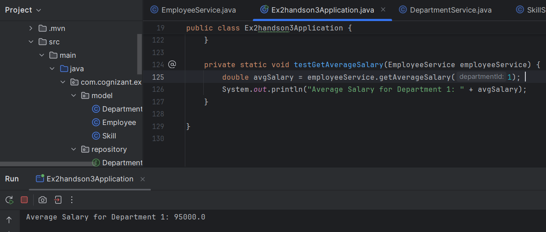

Actual employee table in mysql :

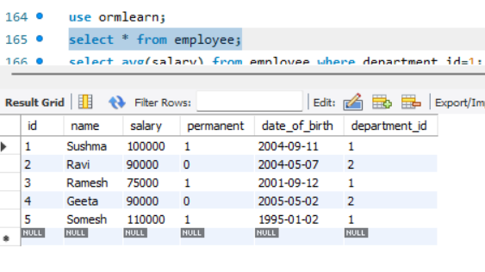

The average salary where department_id=1 :

